TransformAZ
────────────────────────────────────────

Designing the Digital Backbone
A Transformation Strategy for Taylor Inc.
Client | Taylor Group
Date | March 2026
Reference | TAZ-TG-2026-02

Strategic Proposal
Confidential

01 — THE OPPORTUNITY

95 Years of Growth. A Defining Moment for Transformation.

95 yrs  LEGACY | $85M  REVENUE | +300  EMPLOYEES | $128B  MARKET SIZE

Taylor Inc.has grown organically for decades into an enterprise-scale operation —, over 300 employees and a global footprint across 40+ countries.. This growth has been powered by processes built organically over time. Not through a unified system, but through the strength, experience, and adaptability of its people..
The question is no longer whether Taylor has succeeded — it’s what becomes possible when that capability is supported by the right digital foundation.
The experiential marketing industry is at an inflection point representing a $128B global market. The landscape is shifting: faster execution, shorter timelines, higher expectations.. The companies that will thrive are those with smarter, more efficient systems — designed to enable consistent, scalable execution.
Taylor stands at the edge of a meaningful opportunity — to design the system that enables its next phase of growth.

““It’s a pretty unique business. It’s fun, it has a lot of breadth and depth, and it’s constantly evolving. But we’re all very busy servicing clients and staying on the business.”
— Taylor Group Leadership

02 — The New Operating Paradigm

From technology adoption to system-level performance

We are in the midst of a new industrial shift — the most significant transformation in operating models since the digital and industrial revolutions. This shift is driven by the convergence of artificial intelligence, data, automation, and connected systems. But its impact is not primarily technological. It is organizational.
Most organizations are still approaching this shift through a Reactive Adoption* — introducing tools, piloting use cases, and enabling teams to experiment. The data reflects the limitations of this approach:

Only ~20–30% of AI initiatives move beyond pilot into scaled deployment. Most value remains trapped in isolated use cases, rather than embedded into core workflows across the business.

A different pattern is emerging among leading organizations.

They are not focused on point solutions but on Designed Transformation** — reviewing workflows alongside technology adoption, investing in data integration and cross-functional visibility, and scaling solutions across the enterprise rather than within individual teams.

The gap is no longer defined by access to technology. It is defined by how the operation itself is designed.

 | Reactive Adoption* | Designed Transformation**
Starting Point | Tools & use cases | End-to-end workflows
Focus | Task optimization | System redesign
Implementation | Pilots & experiments | Scaled transformation
AI Role | Assistant to individuals | Embedded in execution
Data | Fragmented across systems | Integrated across functions
Impact | Localized improvements | Enterprise-wide performance
Scalability | Limited | Built to scale
Outcome | More activity | Better performance

THE COST OF WAITING
Every quarter without a unified digital strategy compounds inefficiencies, increases cost, and widens the competitive gap.

20–30%  Lower operational efficiency  → Due to fragmented systems | 40%  Slower execution cycles  → Compared to digitally enabled peers | 15–25%  Higher Oeprational Cost | 2–3x  Growth rate for digitally mature competitor
Referencias link a Bibliografía

02 — KEY FINDINGS

What Initial Interviews Revealed

The new paradigm is not theoretical. It is already playing out across Taylor’s day-to-day operations.

Initial conversations point to a clear pattern: Not a lack of capability —but a lack of system-level connection.

* Findings are based on initial conversations and directional estimates. Actual impact may vary — figures will be validated and refined as part of the diagnostic phase.

Aggregate Estimated Impact: $1.6M – $2.85M annually

1. Asset Management Blind Spot [HIGH IMPACT]
$500K – $1.2M / year
Estimated annual impact

“We probably have somewhere between $20 and $30 million worth of assets in our warehouses. And honestly, I couldn’t tell you exactly what we have.” — Dean
Without centralized asset tracking, teams rebuild what already exists across three warehouses and 40+ countries.

Rationale Estimated 5–10% annual inefficiency from lost, unused, or duplicated assets. Additional costs from redundant fabrication and logistics
2. Sales ↔ Production Disconnect [HIGH IMPACT]
$400K – $800K / year
Estimated annual impact

“Sales will sell something and then production finds out and goes, ‘Wait, we can’t do that in that timeline.’” — Dean
Sales operates without visibility into production capacity, leading to over-promises and margin erosion.

Rationale: Based on observed workflow patterns and typical cost structures in custom build environments:
- 15–30% of projects are impacted by sales ↔ production misalignment
- Each affected project incurs $10K–$25K in combined impact (redesign, rush production and logistics, margin compression)
- Based on an estimated 40–80 projects per quarter
3. Executive Time Drain [MEDIUM IMPACT]
$225K – $300K / year
Estimated annual impact

“I get 400 to 500 emails a day. I’d say 70% are CCs where I don’t really need to be included.” — Dean
Senior leadership time is consumed by low-value communication — reducing focus on strategic decisions and operational alignment.
Rationale: 400–500 emails/day with ~70% low-value or unnecessary. Estimated 2–3 hours/day of executive time lost Based on average executive cost of $150–$250/hour

4. Underutilized Technology Investment [MEDIUM IMPACT]
$75K – $200k / year
Estimated annual impact

“We’re paying for ClickUp Brain but nobody’s really using it.” — Mike
Technology investments are already in place — but without adoption, integration, and shared workflows, their value erodes over time.
rationale: ~$60K–$130K annual investment across core tools (ClickUp, M365, AI tools). Estimated 40–70% underutilization due to fragmented adoption and lack of integration. Lost productivity and coordination value typically 2–3x tool cost

5. Generational Adoption Gap [STRATEGIC]
$200k - $500k
Estimated annual impact

“The younger employees pick things up instantly. Some of our senior people... it’s a harder conversation.” — Dean
ANNUAL IMPACT: Every month of delayed adoption costs momentum. 6-month delays double transformation costs.

Technology adoption is inconsistent across the organization. Junior and technical teams adopt new tools quickly. But adoption at the management layer lags — creating bottlenecks in approvals, decision-making, and execution flow

rationale: ~20–30 managers involved in approvals / decision layers. 5–10 hours/week lost per manager due to friction (tool gaps, back-and-forth, manual processes). Avg loaded cost: ~$120–150/hour.6. Missing Strategic Tech Layer [STRATEGIC]

$200K – $400K / year
Estimated annual impact

“We don’t have a CTO. We’ve never had someone whose job is to look at all of this holistically.” — Dean

Technology decisions are made in isolation — by function, by need, and in real time. Without a central owner, tools, data, and workflows evolve independently rather than as a system.
Rationale: Direct Waste: $15K–$60K. Workarounds: $90K–$300K. Lost leverage: $100K–$400K

“Not new software. New connective tissue.”
03 — THE DIGITAL BACKBONE

One Connected Operation
Taylor’s operation is structured across three core modes of value creation: Create, Build, and Execute.
These modes define how ideas are developed, how they are produced, and how they are ultimately delivered. Together, they represent the full lifecycle of Taylor’s work — from concept to execution.
These modes are supported by five foundational layers:
People & Culture,
Processes,
Technology,
Data,
Compliance.
[IMAGEN DE LOS TRES MODOS Y LOS 5 PILARES = DESCONECTADOS]
Each of these layers plays a critical role in how the business runs. Work moves across Create, Build, and Execute through a combination of tools, handoffs, and individual coordination. Information is distributed across systems. Visibility is partial. Alignment depends on people rather than structure. —.
The Digital Backbone addresses this gap
It introduces a connected operational layer that links how work is created, built, and executed across the organization. Rather than adding new systems, it connects existing ones — enabling workflows to move end-to-end, data to flow in real time, and decisions to be made with full visibility.
It integrates the three modes of operation with the five foundational layers — turning them into a single, coordinated system.
[IMAGEN DE LOS TRES MODOS Y LOS 5 PILARES = CONECTADOS A TRAVÉS DEL DIGITAL BACKBONE]

🔹 Hover: CREATE
CREATE — Strategy & Creative
Boxes
- Strategic Intelligence
  - Client history, market context, and prior work available at the start of every brief
- Creative Memory
  - Searchable archive of concepts, proposals, and past builds
- Proposal Acceleration
  - Faster response using reusable materials and pricing logic
- Operational Awareness
  - Early visibility into production complexity and available assets
- AI-Assisted Ideation
  - Faster concept expansion and synthesis of inputs
More informed. Faster. Grounded in reality.

Before | After
Ideas start from scratch, proposals assembled manually, institutional knowledge lives in people’s heads | Institutional memory searchable, proposals accelerated, creative ambition grounded in operational reality

🔹 Hover: BUILD
BUILD — Experiences & Fabrication
Boxes
- Design-to-Build Continuity
  - Shared context across creative, digital, and production teams
- Asset Intelligence
  - Visibility into reusable builds, components, and materials
- Material Planning
  - Clear view of needs, availability, and procurement
- Capacity Forecasting
  - Production load and team availability visible upfront
- Cost Intelligence
  - Pricing informed by historical builds and benchmarks
More coordinated. Predictable. Reusable.

Before | After
Sales sells blind, assets rebuilt because nobody knows they exist, each office runs its own way | Design-to-build continuity, searchable asset inventory, planned production, cost intelligence from history

🔹 Hover: EXECUTE
EXECUTE — Program Management
Boxes
- Project Orchestration
  - Centralized visibility across timelines, ownership, and dependencies
- Resource Allocation
  - Better crew planning and cross-project visibility
- Logistics & Deployment
  - Clear sequencing, readiness, and delivery tracking
- Real-Time Visibility
  - Project status visible without manual follow-up
- Measurement & Learning
  - Performance data feeds future strategy

Before | After
Status via email chains, reactive fire-fighting, post-event learnings lost, no unified view | Real-time visibility, connected execution, organizational learning compounds over time

Five dimensions. Three phases. One backbone. The Digital Backbone makes Taylor more informed in Create, more coordinated in Build, and more governed in Execute. It doesn’t add complexity — it removes the friction that 95 years of organic growth naturally created.

Five Dimensions Across Every Phase
Dimension | Description
People & Culture | Segmented adoption paths for executives, operations, and creative teams. Internal champions program. Skills development roadmap. Culture-first change management.
Processes | SOP modernization. Sales-to-production alignment with real-time capacity visibility. Asset management lifecycle. Cross-office standardization.
Tech Integrations | ClickUp architecture optimization + Brain activation. Gemini integration. Automation engine (10–15 priority workflows). Global Core ↔ Operations tool alignment.
Data | Asset inventory intelligence. Production capacity data. Project profitability tracking. Executive dashboards. Performance feedback loops.
Compliance | AI governance policy. Data handling standards. IP protection strategy. Regulatory readiness for pharma and healthcare clients.

Five dimensions. Three phases. One backbone. The Digital Backbone makes Taylor more informed in Create, more coordinated in Build, and more governed in Execute.

04 — The TRANSFORMATION APPROACH

From insight to system-level execution

The Digital Backbone is not deployed. It is built.
The transformation is not approached as a technology rollout — but as a redesign of how the organization operates.
It is structured, phase-based, and built to move from initial alignment to full system activation — ensuring that change is not introduced in isolation, but embedded across the business.
The approach follows a clear progression:
- Alignment before action
- Understanding before design
- Validation before transformation
- Execution based on evidence
- Stabilization & Optimization
Each phase builds on the previous one — reducing ambiguity, increasing precision, and enabling confident decision-making.

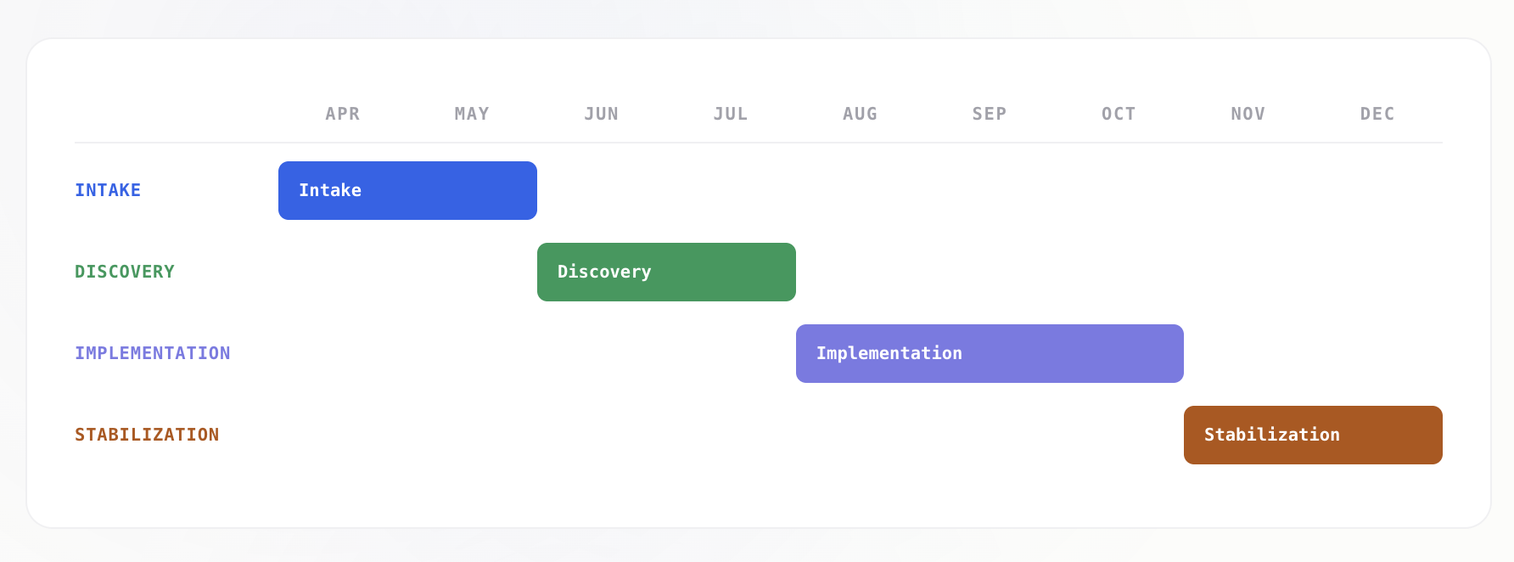

This framework:
- Moves from fragmented understanding to validated operational clarity
- Ensures decisions are grounded in evidence, not assumption
- Connects workflows, systems, data, and decision-making
- Enables transformation to be sequenced, not improvised
- Aligns leadership, teams, and execution under a shared system
Transformation is not introduced.
It is engineered — phase by phase, based on evidence.

The Phases

PHASE 0
PRE-ENGAGEMENT
April 2026
Remote
Alignment is established across scope, structure, and expectations. This phase defines how we will work together — and concludes with the formalization of the engagement.
Key Milestones
- Define Scope & Objectives
- Establish Governance & Ways of Working
- Confirm Team & Resourcing
- Finalize Commercials & Agreement

Outcome: Signed agreement and engagement ready to begin

[link to full phase breakdown]

PHASE 1
INTAKE
Apr – May 2026
Remote
The Intake phase sets the foundation for Discovery. It focuses on collecting information, gaining access to systems, and building an initial understanding of how the business operates — before any on-site work begins.
Key Milestones
- Set up data room & information structure
- Collect core documentation (SOPs, org, systems)
- Gain access to tools, platforms, and workflows
- Review documentation and data flows
- Define Discovery plan (interviews, workflows, focus areas)
- Initiate leadership alignment & early engagement

Outcome: Structured understanding of the current operation and a fully defined Discovery plan

[link to full phase breakdown]

PHASE 2
DISCOVERY
Jun – Jul 2026
Onsite Toronto + Remote
The Discovery phase translates structured inputs into validated operational understanding. Through on-site observation, stakeholder interviews, and workflow validation, this phase identifies where value is created, where friction accumulates, and where transformation should be focused.
- Conduct kickoff and align Discovery agenda
- Execute leadership and functional interviews
- Observe operations on-site (core workflows)
- Validate workflows, systems, and decision-making
- Identify gaps, redundancies, and breakdowns
- Consolidate findings and validate with leadership

[link to full phase breakdown]

PHASE 3
IMPLEMENTATION
Aug – Oct 2026
Hybrid
The Implementation phase activates the transformation roadmap defined during Discovery. At this stage, the Digital Backbone is built in practice — redesigning workflows, connecting systems, and embedding new ways of operating across the organization.
The exact scope, sequencing, and priorities of this phase are defined based on the validated findings and roadmap produced in Discovery.
Key Milestones
- Prioritized initiatives based on Discovery outputs
- Workflow redesign and system activation
- Integration across tools, data, and teams
- Rollout of new operating model
Governance and performance tracking established
- Activated platforms
- Built automations
- Trained champions
- Measurable KPIs

PHASE 4
STABILIZATION & OPTIMIZATION
Nov 2026+
Remote

Workflows are implemented, systems are connected, and the Digital Backbone is embedded into day-to-day operations. The focus is not only on execution — but on ensuring that the new operating model performs consistently and improves over time.
- Adoption monitoring
- Optimization recs
- Quarterly reviews
- Knowledge transfer

PHASE X
CHANGE ENABLEMENT
Nov 2026+
Remote
Transformation does not happen through design alone — it happens through adoption.
This layer runs across the entire engagement, ensuring alignment, clarity, and engagement at every stage. It supports how the transformation is understood, communicated, and embedded within the organization.
From early stakeholder alignment to ongoing communication and reinforcement, this phase ensures that changes are not only implemented — but sustained.

Key Milestones
- Implement prioritized initiatives from the roadmap
- Activate redesigned workflows across teams
- Integrate systems and align data flows
- Establish governance and operating rhythms
- Monitor performance and resolve early friction
- Optimize processes based on real usage and feedback

“Only 16% of digital transformations fully succeed. Approach matters more than ambition.”
— McKinsey
“Everyone is buying AI tools. Almost nobody is connecting them. The ones who wire it into how they actually work — they won’t just compete. They’ll set the rules.”

PHASE 0 - PRE-ENGAGEMENT

PRE-ENGAGEMENT: Alignment Becomes Commitment
This Phase formalizes the foundation on which the transformation will operate. It translates initial conversations into a structured engagement model — defining scope, governance, resourcing, and ways of working. This phase ensures that both parties move from alignment in principle to alignment in execution.

Rather than beginning work prematurely, this phase reduces ambiguity across strategic, operational, and contractual layers — ensuring that the transformation starts with clear ownership, defined expectations, and a shared operating model.

2 WEEKS  DURATION | REMOTE  COLLABORATION | 5  AREAS OF WORK | 1  MASTER SERVICE AGREEMENT

Operating Model of the Phase
- Executive alignment across transformation objectives and scope
- Definition of governance structure (Sponsor, SteerCo, decision model)
- Establishment of communication cadence and reporting structure
- Alignment on tools, collaboration model, and ways of working
- Definition of team structure and resource allocation
- Commercial alignment (pricing, scope, terms)
- Iterative working sessions with leadership to validate decisions

What This Phase Does Not Do
- No operational assessment or workflow analysis
- No data collection or system deep dives
- No hypothesis building or diagnostics
- No implementation or solution design

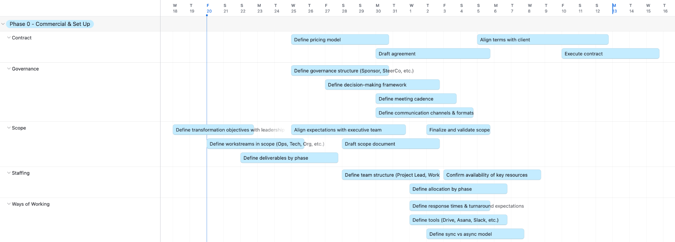

PHASE 1 — INTAKE

INTAKE: Setting the Ground for Discovery
This phase establishes a controlled environment where fragmented information — across workflows, systems, data, and organizational structure — is centralized, validated, and made analyzable. This phase enables a first-pass reconstruction of how the business actually operates, beyond how it is described.
Through structured data collection, system access provisioning, and documentation review, Intake creates the conditions for understanding the operational model of the organization. This model informs where value is created, where friction accumulates, and where deeper investigation is required.
In parallel, the phase defines the Discovery strategy — identifying critical workflows, prioritizing stakeholders, and sequencing investigative efforts based on early signals.
The objective is not to solve — but to reduce ambiguity to a level where targeted intervention becomes possible.

1 mo  DURATION | REMOTE  COLLABORATION | 3  CORE FLOWS MAPPED | 5  DIMENSIONS ASSESSED

Operating Model of the Phase
- Fully remote execution
- Early engagement with leadership group
- Initial cadence of working sessions established
- Stakeholders identified and aligned
- Discovery sessions pre-scheduled

What This Phase Does Not Do
- No process redesign
- No system changes
- No implementation decisions
This phase builds clarity — not solutions.

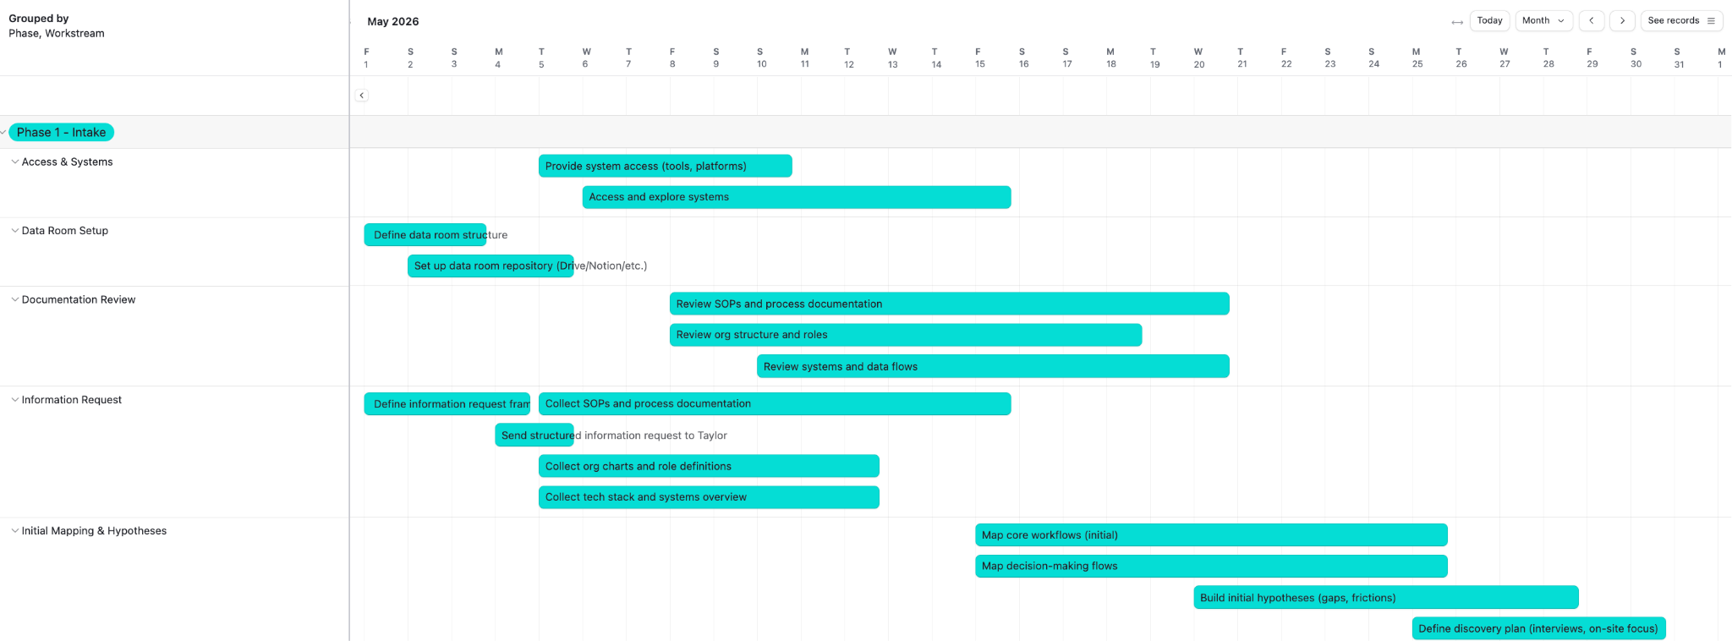

PHASE 2 - DISCOVERY

From Visibility to Validated Understanding
Building on the foundation established during Intake, this phase moves into direct observation and engagement with the organization. It combines qualitative and quantitative inputs — interviews, workflow observation, and system validation — to reconstruct how the business actually operates in practice.
Rather than relying on documentation or perception, Discovery tests assumptions against reality. It identifies where workflows break, where decisions stall, where systems fail to connect, and where inefficiencies compound across the operation.
This phase produces a validated diagnosis of the current state — grounded in evidence, not interpretation.

2 mo  DURATION | HYBRID  COLLABORATION | 5  PILLARS ASSESSED | 1  TRANSFORMATION ROADMAP

Operating Model of the Phase
- Hybrid execution (on-site + remote)
- High-touch engagement with leadership and teams
- Direct observation of workflows in action
- Iterative validation of findings with stakeholders
- Continuous refinement of hypotheses

Outcome
- Current-State Report: A validated, end-to-end diagnosis of workflows, systems, data, and decision-making
- Transformation Roadmap: A prioritized and sequenced set of initiatives defining how the operation will be redesigned
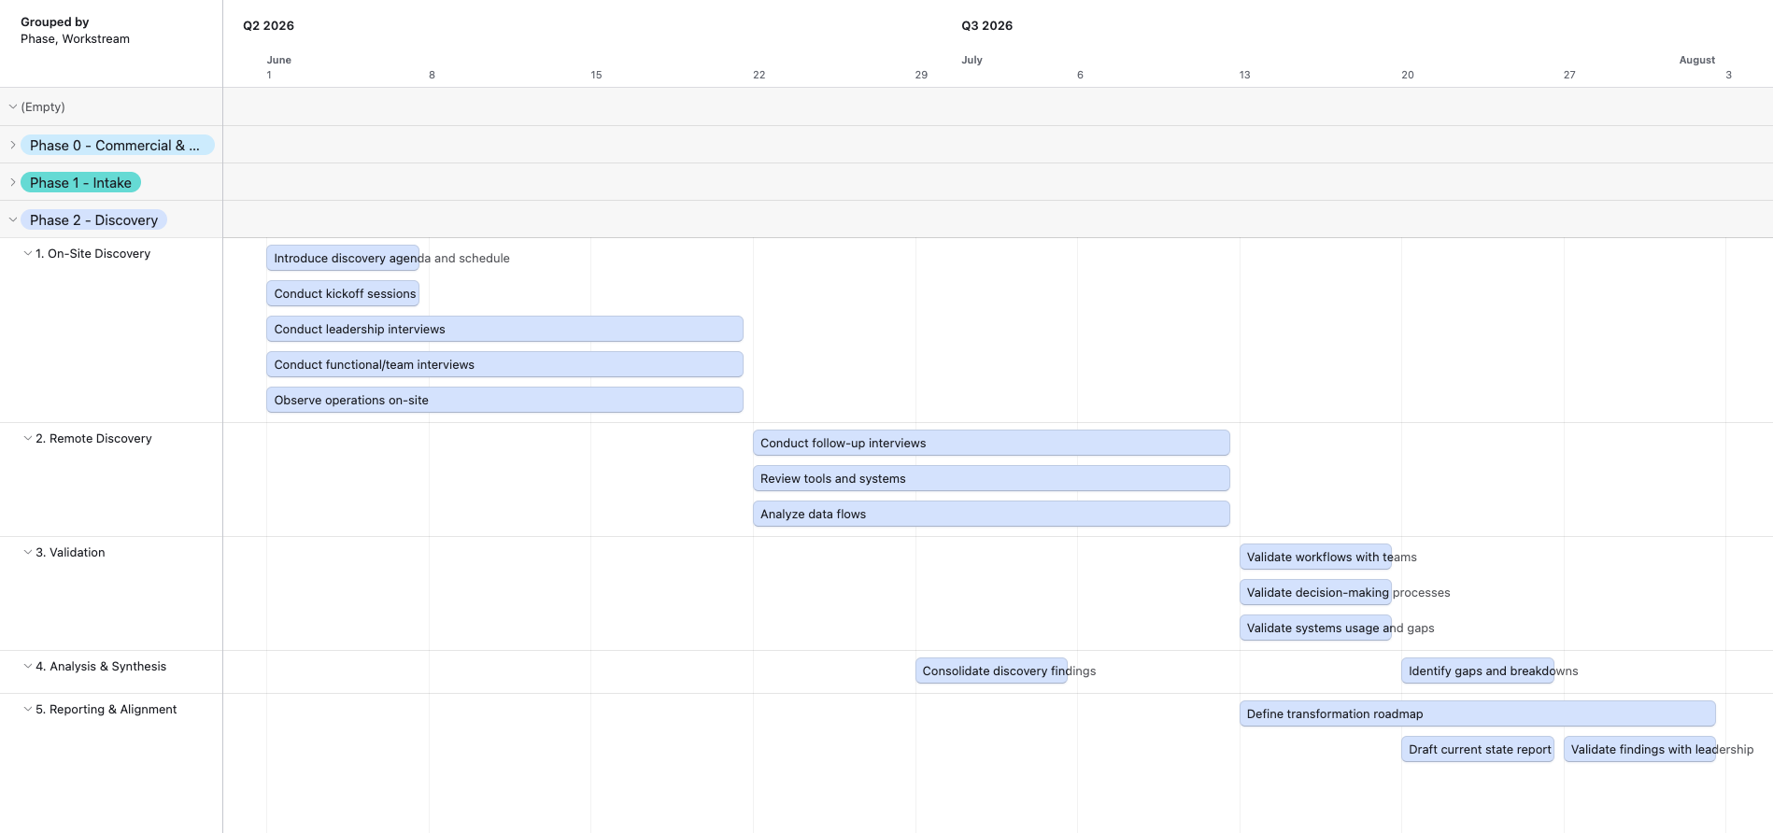

00 - SERVICES & INVESTMENT

The engagement is structured as a phased service model — allowing Taylor to move from diagnosis to execution with clarity and control.
Each phase is scoped independently, with a defined set of services, deliverables, and investment structure.

Phase | Duration | Format | TRANSFORMAZ SERVICE | Investment
0 — PRE-ALIGNMENT | 2-3 weeks | Remote | DIAGNOSIS | Fixed project fee
1 — INTAKE | 4–6 weeks | Remote
2 — DISCOVERY | 8-10 weeks | On-site + Remote
3 — IMPLEMENTATION | Monthly | Hybrid | EXECUTION | Monthly retainer
4 — STABILIZATION & OPTIMIZATION | Monthly | Hybrid |  | Monthly retainer
X — comms and change | Monthly | Remote | DIAGNOSIS and/or EXECUTION | Fixed Project Fee or Monthly Retainer

Your Investment
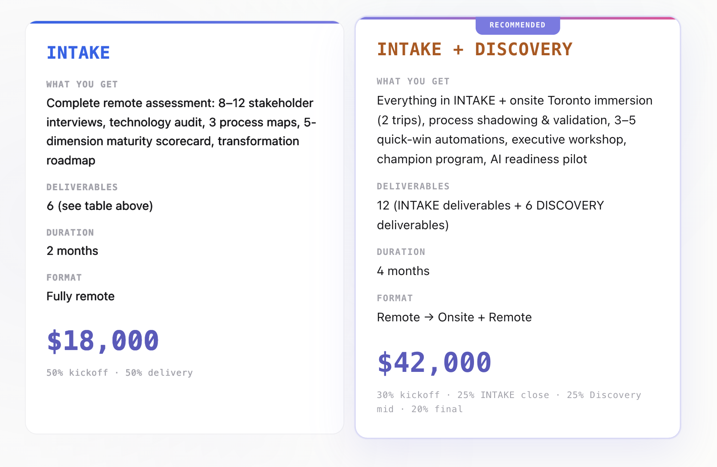

DIAGNOSIS

Intake + Discovery  Format: Hybrid  Duration: 3 months  Deliverables  - Structured Intake (Remote)  - 3-Week On-Site Immersion  - Leadership & Functional Interviews  - Workflow & Process Assessment  - Systems & Data Review  - Validation Sessions  - Analysis & Diagnosis  - Transformation Roadmap Design | Intake + Discovery + Change Enablement  Format: Hybrid  Duration: 3 months  Includes everything in Option 1, plus Phase x:  - Communication & Change Strategy  - Leadership Alignment & Messaging  - Stakeholder Engagement Framework  - Ongoing Communication Cadence  - Change Enablement Across Teams  - Adoption & Reinforcement Mechanisms

06 — MARKET INSIGHTS

The AI Transformation Landscape
88% of enterprises now use AI — but only 34% are truly reimagining their business. Here’s where the industry stands, and why Taylor’s timing is strategic.

88%  AI ADOPTION  McKinsey 2025 | 53%  PRODUCTIVITY BOOST  McKinsey/WEF 2025 | 500%  PREDICTIVE MAINT. ROI  Tech-Stack 2025 | $155B  AI IN MFG BY 2030  Industry Reports

Industry Evolution
Year | Milestone | Description
2025 | AI Copilots | Copilot, Gemini, ClickUp Brain — AI assists, humans decide
2026 | AI Agents | AI acts autonomously — books, flags, follows up
2029 | Connected Systems | Machines talk to each other, predict failures
2032 | Digital Twins | Test spaces and layouts virtually before building
2036 | AI End-to-End | Concept to logistics, fully orchestrated

Taylor Group’s AI Journey
Year | Milestone | Description
2026 | Digital Backbone | Audit, quick wins, first agents deployed
2027 | AI-Powered Ops | Automated proposals, predictive logistics
2029 | Autonomous Ops | Agents run staffing, logistics, reporting
2032 | Experience Twins | Test events and spaces virtually, iterate fast
2036 | Industry Leader | A century of knowledge, fully activated by AI

Horizon 1: Now → 12 months
- 88% of orgs use AI in at least one function; worker access rose 50% in 2025 — McKinsey
- Lighthouse factories: 53% labor productivity boost, 26% cost reduction — McKinsey/WEF
- 95% of manufacturers invested or planning to invest in AI automation — Tech-Stack
- Microsoft 365 Copilot now ships agentic capabilities at $30/user/month
- Quick wins available now: the tools Taylor already owns are evolving fast

Horizon 2: 1–3 Years
- Agentic AI replaces chatbots — Microsoft 2026 Wave 1: autonomous agents in Dynamics 365
- By 2026: 45% of G2000 OEMs connect field + engineering data via AI — IDC
- Digital twins: $24.5B market, ~75% adoption in advanced industries — McKinsey
- Predictive maintenance: 300–500% ROI; computer vision QC: 200–300% ROI — Tech-Stack
- Jack Morton + Impact XM merged (Jan 2026) — competitors consolidating around data platforms

Horizon 3: 5–10 Years
Where We See Taylor Group in 2036
- AI in manufacturing: $34B → $155B by 2030 at 35% CAGR — backbone builders become leaders
- Digital twin market: $24.5B today, projected to exceed $250B by 2034 — virtual replicas of warehouses, assets, spaces
- By 2028: 65% of G1000 manufacturers integrate AI agents into design/simulation — IDC
- By 2029: 30% of factories manage controls centrally via open automation platforms — IDC
- Taylor’s 95 years of institutional knowledge + Digital Backbone = moat AI-only entrants can’t replicate

The gap isn’t between companies that use AI and those that don’t. It’s between those that connected their AI into a backbone — and those still running pilots.

What Your Competitors Are Doing
Jack Morton + Impact XM
Merged in January 2026 to combine their client lists and data. Their bet: one bigger company with shared measurement tools can win more enterprise contracts — and prove ROI faster.
They’re getting bigger to move faster. Scale is their strategy.

Freeman
The largest event services company in the industry. Already using virtual/augmented reality in activations and AI to manage event logistics. They measure everything digitally.
They’re not experimenting — they’re operating with AI today.

George P. Johnson (GPJ)
Part of Project Worldwide. Building experiences that blend physical and digital — from design through production. Using technology across the entire creative process.
They’re embedding tech into every step, not just the final event.

Your competitors aren’t waiting. Taylor’s advantage: 95 years of institutional knowledge and a team ready to activate — but that window won’t stay open.

THE TRANSFORMATION REALITY
Only 16% of digital transformations fully succeed — McKinsey 2025. Only 39% report enterprise-level EBIT impact from AI. 53% average productivity boost in Lighthouse factories — McKinsey/WEF 2025. ~75% of advanced-industry companies have adopted digital twin technology. Everyone is buying AI tools. Almost nobody is connecting them.
Sources: McKinsey State of AI 2025 · McKinsey/WEF Global Lighthouse Network 2025 · IDC FutureScape 2026 · MarketsandMarkets 2025

07 — NEXT STEPS

Moving Forward
Phase | Duration | Format | Investment
INTAKE | 2 months | Remote | Fixed project fee
DISCOVERY | 2 months | Onsite + remote | Fixed project fee
IMPLEMENTATION | 12 weeks | Hybrid | Monthly retainer
STABILIZATION | Ongoing | Remote | Advisory retainer

What Taylor Gets
- INTAKE: Current-state assessment, technology audit, stakeholder map, scoped proposal for next phases.
- DISCOVERY: Process maps, AI readiness evaluation, quick-wins, implementation roadmap.
- IMPLEMENTATION: Activated platforms, automations, trained champions, measurable KPIs.
- STABILIZATION: Adoption monitoring, optimization, quarterly reviews, knowledge transfer.

If the assessment confirms the opportunity, we proceed. If not, Taylor walks away with a valuable operational audit at minimal cost.

INTAKE Deliverables
Deliverable | Format | Description
Current-State Assessment | Report (PDF) | Executive summary of findings across all 5 dimensions
Technology Stack Audit | Spreadsheet + Report | Every tool, utilization score, integration status, recommendations
Stakeholder Interview Findings | Report | Synthesized themes, pain points, opportunities by department
Process Maps (×3) | Visual diagrams + narrative | Sales-to-Production, Creative-to-Fabrication, Executive Operations
Digital Maturity Scorecard | Interactive dashboard | Five-dimension scores with benchmarks and gap analysis
Transformation Roadmap | Presentation + Report | Prioritized workstreams, phasing, investment ranges, scoped Discovery proposal

What DISCOVERY Adds
DISCOVERY extends the INTAKE with onsite validation in Toronto and tangible quick wins. Taylor doesn’t just get a report — Taylor gets results.
Deliverable | Format | Description
Validated Process Maps | Updated diagrams | INTAKE maps refined with onsite shadowing — observed reality vs. interview data
Quick-Win Automations (×3–5) | Live in production | ClickUp/M365 automations targeting highest-friction points, with documentation
AI Readiness Report | Report + Pilot Plan | ClickUp Brain activation strategy, M365 Copilot assessment, pilot design
Champion Playbook | Guide + Materials | 2–3 champions per division identified, training framework, program kickoff
Executive Workshop | Half-day session | Findings, roadmap, and change management framework with leadership team
Implementation Proposal | Presentation + Report | Scoped next phase with timelines, resources, costs, and KPIs

Your Investment
Two paths forward. The INTAKE stands alone as a complete diagnostic. Or combine it with DISCOVERY to validate findings onsite and leave with automations already working.
INTAKE
WHAT YOU GET: Complete remote assessment: 8–12 stakeholder interviews, technology audit, 3 process maps, 5-dimension maturity scorecard, transformation roadmap
DELIVERABLES: 6 (see table above)
DURATION: 2 months
FORMAT: Fully remote
$18,000
50% kickoff · 50% delivery

★ RECOMMENDED
INTAKE + DISCOVERY
WHAT YOU GET: Everything in INTAKE + onsite Toronto immersion (2 trips), process shadowing & validation, 3–5 quick-win automations, executive workshop, champion program, AI readiness pilot
DELIVERABLES: 12 (INTAKE deliverables + 6 DISCOVERY deliverables)
DURATION: 4 months
FORMAT: Remote → Onsite + Remote
$42,000
30% kickoff · 25% INTAKE close · 25% Discovery mid · 20% final
Fixed project fee. Travel billed separately at cost. No obligation to proceed to subsequent phases.

Against $1.4M–2.85M in annual operational friction identified in our initial assessment, the INTAKE at $18,000 represents roughly 1% of the problem cost. The full INTAKE + DISCOVERY at $42,000 delivers not just the diagnosis but working automations and a validated roadmap — at less than 3% of the annual friction.
“If the assessment confirms the opportunity, we proceed. If not, Taylor walks away with a valuable operational audit at minimal cost.”

Engagement Terms
Term | Detail
Confidentiality | Full NDA. Findings shared only with designated Taylor leadership.
Scope Protection | If Discovery reveals scope changes, adjustments proposed before proceeding.
Client Dependencies | Access to systems, stakeholder availability, documentation.
Cancellation | Either party, 10 business days written notice.
Travel | Billed at cost, not included in project fee.
No Obligation | INTAKE stands alone — no commitment to subsequent phases.

Let’s Begin — April 2026
The first step is a 30-minute scoping call to align on priorities, confirm stakeholder access, and schedule the kickoff. No preparation needed — we come to you.

TransformAZ — March 2026 — Prepared exclusively for Taylor Group

Supporting Research & References

Operational Efficiency
20–30% lower efficiency in low digital maturity organizations
- McKinsey & Company — The case for digital reinvention
- McKinsey & Company — Unlocking success in digital transformations

Execution Speed / Time-to-Market
30–50% faster execution for digitally enabled organizations
- Deloitte — Agile and Digital Transformation Report
- McKinsey & Company — The impact of agility on business performance

Operational Costs
15–25% higher costs due to fragmented systems and manual processes
- Boston Consulting Group — Flipping the odds of digital transformation success
- McKinsey & Company — The cost of complexity in operations

Growth Performance
2–3x higher growth for digitally mature organizations
- MIT Sloan — Leading Digital
- McKinsey & Company — Digital strategy and corporate performance

